Ganpat University

U.V.PATEL COLLEGE OF ENGENEERING & TECHNOLOGY

DEPARTMENT OF COMPUTER SCIENCE AND ENGG.

B.tech-1st semester

(stream= cloud based application)

Subject- ESFP date- 27/8/2014

Name-Hemant singh enrollment no.-t14012101011

Goal- **: .) Assignment 1**

**1. Write a program to print ASCII values of all backslash characters and white space on screen in following format :**

**The ASCII value of ‘\t’ is : 9**

**(Hint : you can verify your ASCII values with the help of a table for ASCII values from text book)**

**2. Explain different data types available in C.**

**3. Explain about C Tokens in brief.**

**4. Explain about backslash characters in C.**

Answers:

1.)

Coding:

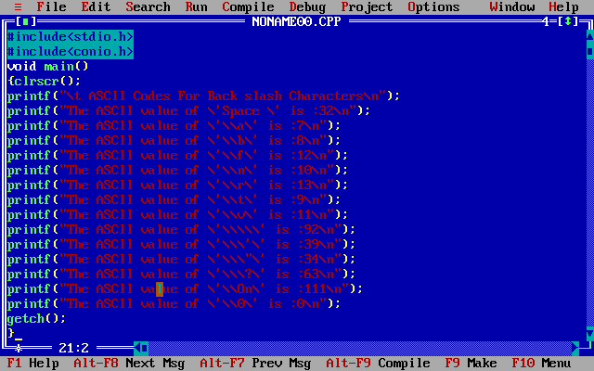

Output:

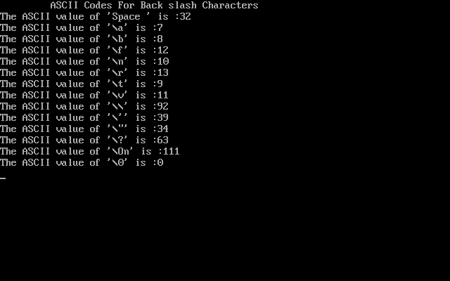

2.)

C language is rich in its data type. It includes following data type:-

* Integer type:

Integers are whole no. with a range of values supported by particular machine. In order to provide some control over the range of no. and storage space ,C has 3 classes of integer storage namely **shortint, int** and **longint,**in both signed and unsigned forms.

* Floating point type:

floating point no. are stored in 32 bits, with 6 digit of precision.floating point no. are defined in C by the keyword **float.**When the accuracy provided by a float no. is not sufficient ,the type double and long double can be use.

* Void:

The void types have no values. This is usually use to spacify the type of function. The type of a function is said to be void when it dosen’t return any value to calling function.

* Character typr:
* A single character can be define as a character (char)type data . The qualifier singned(+and _) or unsigned(+) may be explicitly applied to char.

3.)

Tokens :

•In C Programming, the smallest individual units are known as C tokens.

•C Programs are written using these tokens and the syntax of language.

Tokens are of following type:

1. Keywords
2. Identifiers
3. Constants
4. Strings
5. Special symbols
6. Operators

4.)

•Backslash Characters:



Some type of backslash characters

